Math Attachment Week # 4
Math Game- “Making 10”
GAME- Making 10
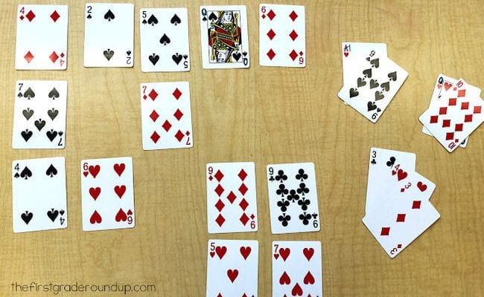
Play this math card game alone or as a team. Lay out 20 cards on the table (leave out face cards or change them to equal 0, while aces equal 1).
Object of the Game:
Take turns, removing sets of cards that add up to 10, ultimately trying to remove all the cards from the table. It’s harder than you think!
Get creative and change it up:
Include the face cards J=11, Q=12, K=13 A=1
Try to add cards together that make a higher total (15 or 20…)
Or
Pick a magic number- use different or multiple operations to create this magic number (For example #19- Pick up a 2,8, and a 3 from the table because:
2 x 8 +3
16 +3 =19

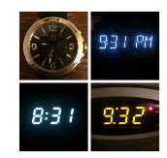
Journal Entry:
Which one does not belong?
Look at the four images in the picture and explain WHY YOU THINK one does not belong. I am not looking for ONE right answer, there are many right answers. I am looking for the one that you think is correct.

Operations Practice:
Find the missing digits to make a true statement:
- 92 + _____ = 176 b)197 - _____ = 62
- 5 x _____ = 65 d) 80 ÷ ____ = 4 e) ____ ÷ 7 = 12
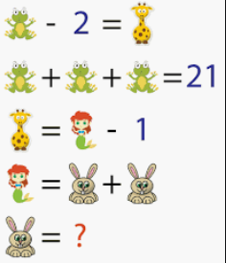
Problem of the Week: Solve this picture Puzzles
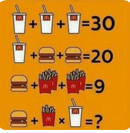
Be careful this one is tricky

